- Create the DTD file with the following constraints:
  - Library has any number of books and members
    - More than one book and member is possible

  - Books has the following elements
    - id
    - name
    - author
    - ISBN

- id, name, author are mandatory fields. More than one author and ISBN number can be possible.

  - Member has the following elements
    - id
    - password
    - name
    - age
    - email
    - phoneNumber
    - panNumber
    - passportNumber

- id, password, name, age fields are mandatory
- email is optional. maximum one email is allowed
- more than one phoneNumber is allowed.
- (passportNumber, panNumber) either this or that is allowed only once
- hightlight emailId, name and author with different color

Create the XML document for at least 10 books and 10 members. Check the XML document for well formness and validity. Write the different variations of the XML document.

- Write the DTD and XML document for the following tree structure

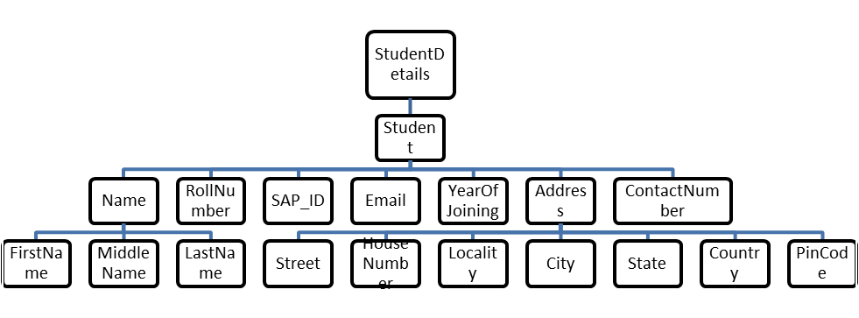
Attribute: id
Check the XML document for validity.

- Element donutBox can have zero or one jelly elements, followed by zero or more lemon elements, followed by one or more creme or sugar elements or exactly one glazed element. Write the DTD and variations of XML document and check their validity.

- Element farm can have one or more farmer elements, any number of optional dog elements or an optional cat element, any number of optional pig elements, an optional goat or cow element and one or more chicken elements or any number of optional duck elements. Write the DTD and variations of XML document and check their validity.

